Complete Product Flow of BIOS Lab System:

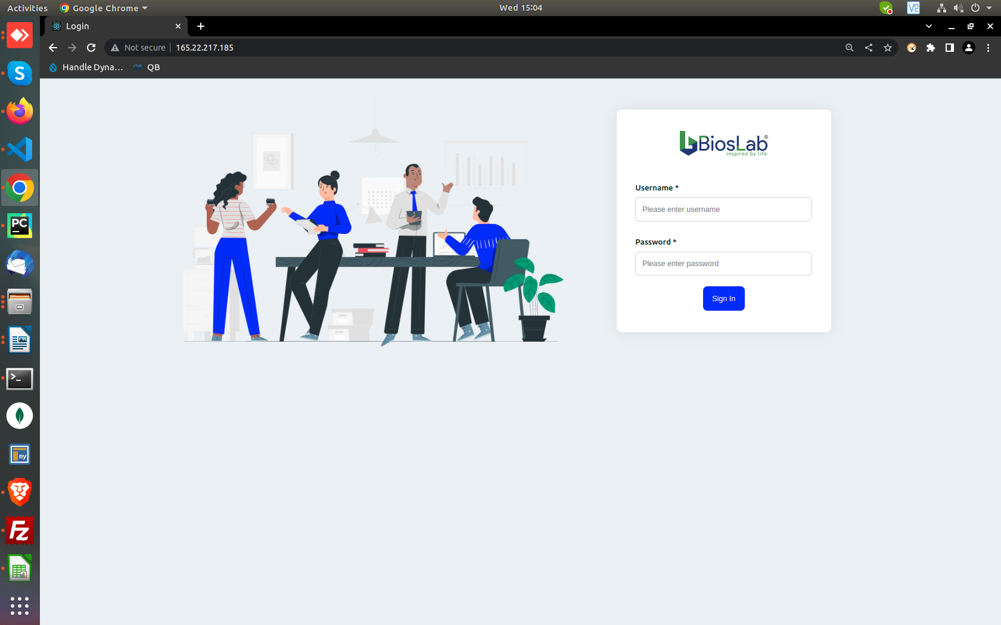
Upon opening the website, User sees this Login page.
Here, there are two types of users,
1) with Admin/MR Manager Privilages
2) with End users/MR Privilages

After enetering their respective credentials, one in diverted on this Dashboard, Giving a basic glance over some useful information ( Employee login in these screenshots)

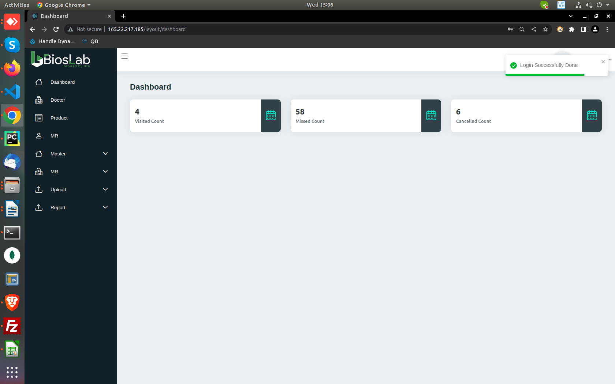
Here, we can see all the options on the left hand side of the screen which includes, Dashboard, Doctor, Product, MR(Medical Representative), Master, MR, Upload and Report

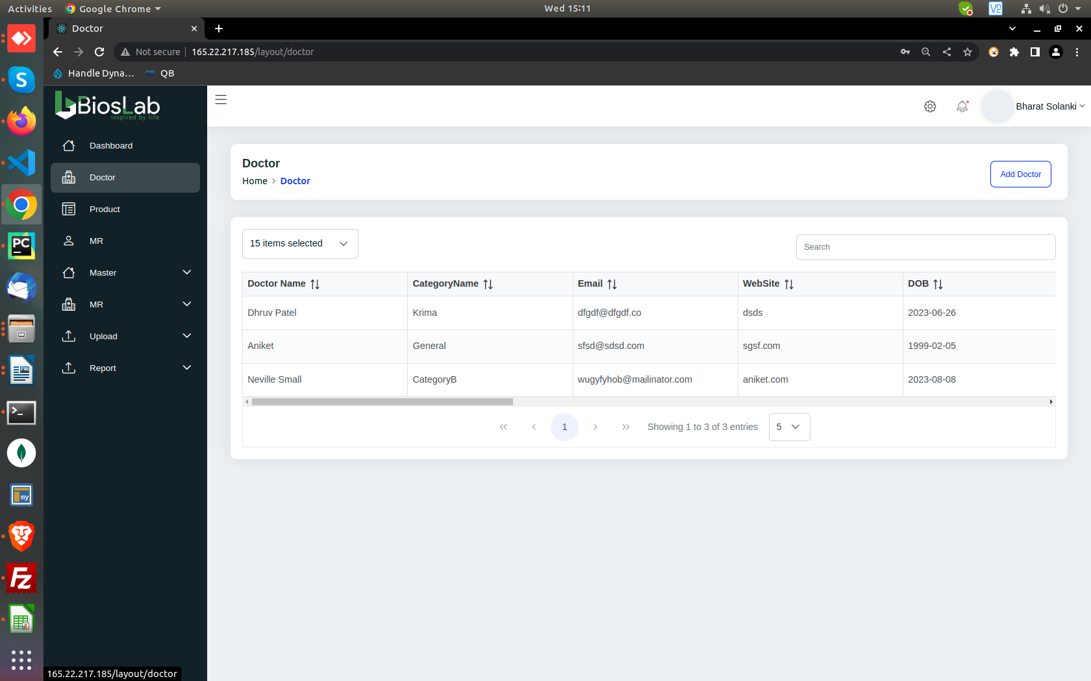
Upon selecting the option Doctor, We can see the basic information of the doctors. Upon scrolling the details scroll bar, we can view the same information in a well designed, separate “Doctor Profile” page as shown.

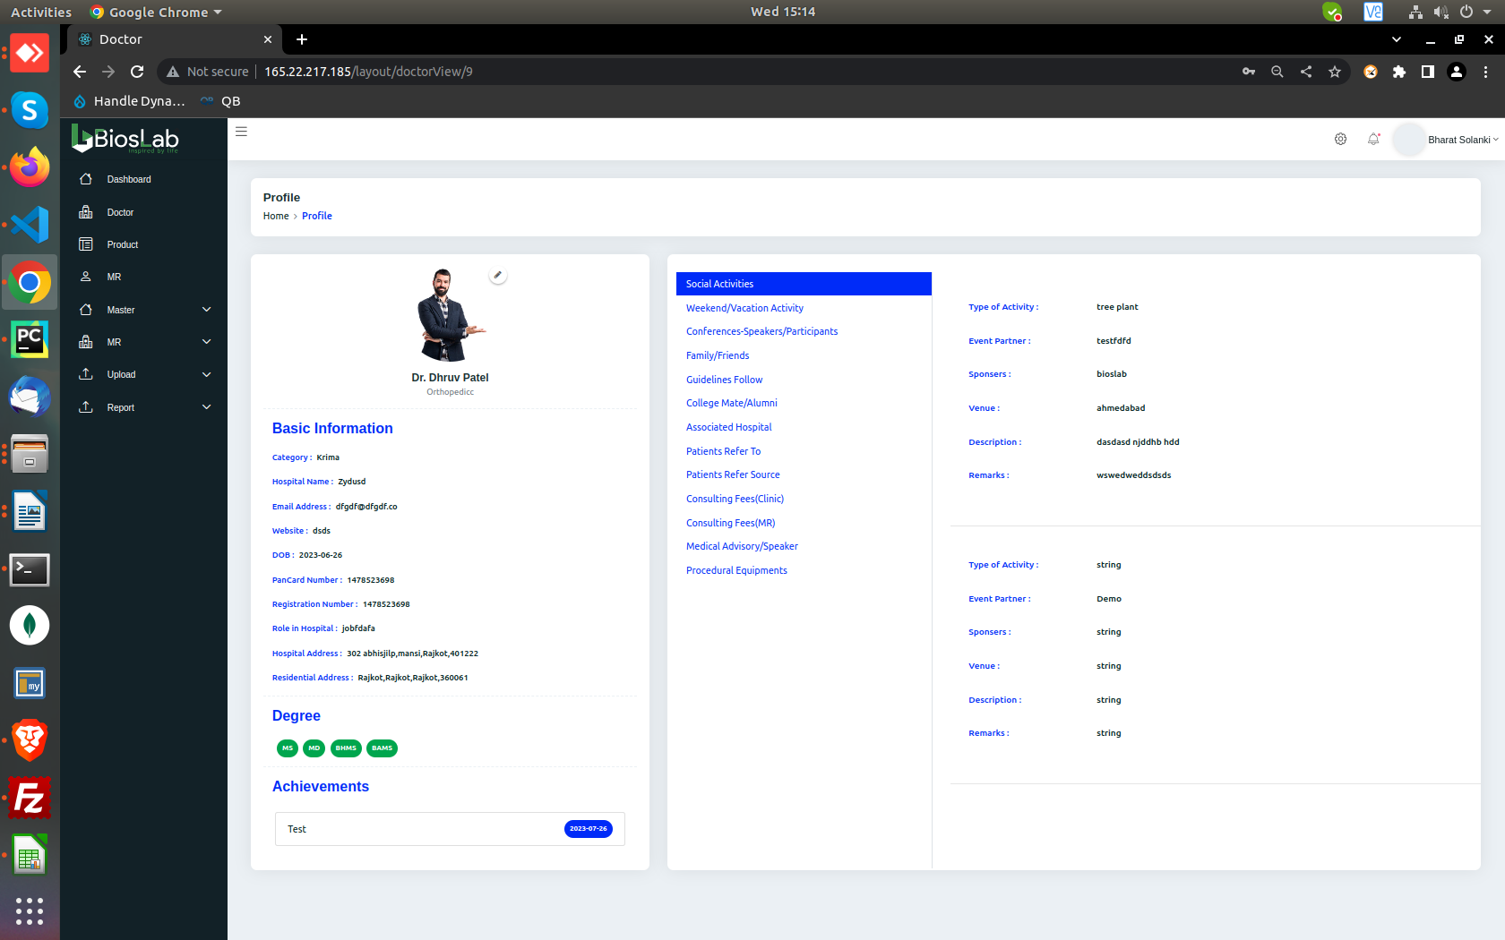
We can view all the information of the selected doctor, starting from very basic personal information like name and age to the very useful information like which hospitals they’re associated at, a few patient details and fees and much more.

We can add,update and delete all these information as expected from the “Edit doctor” menu.

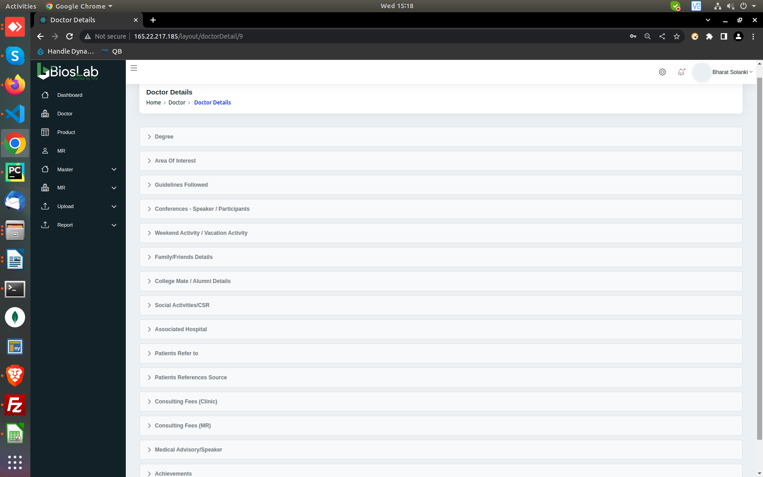

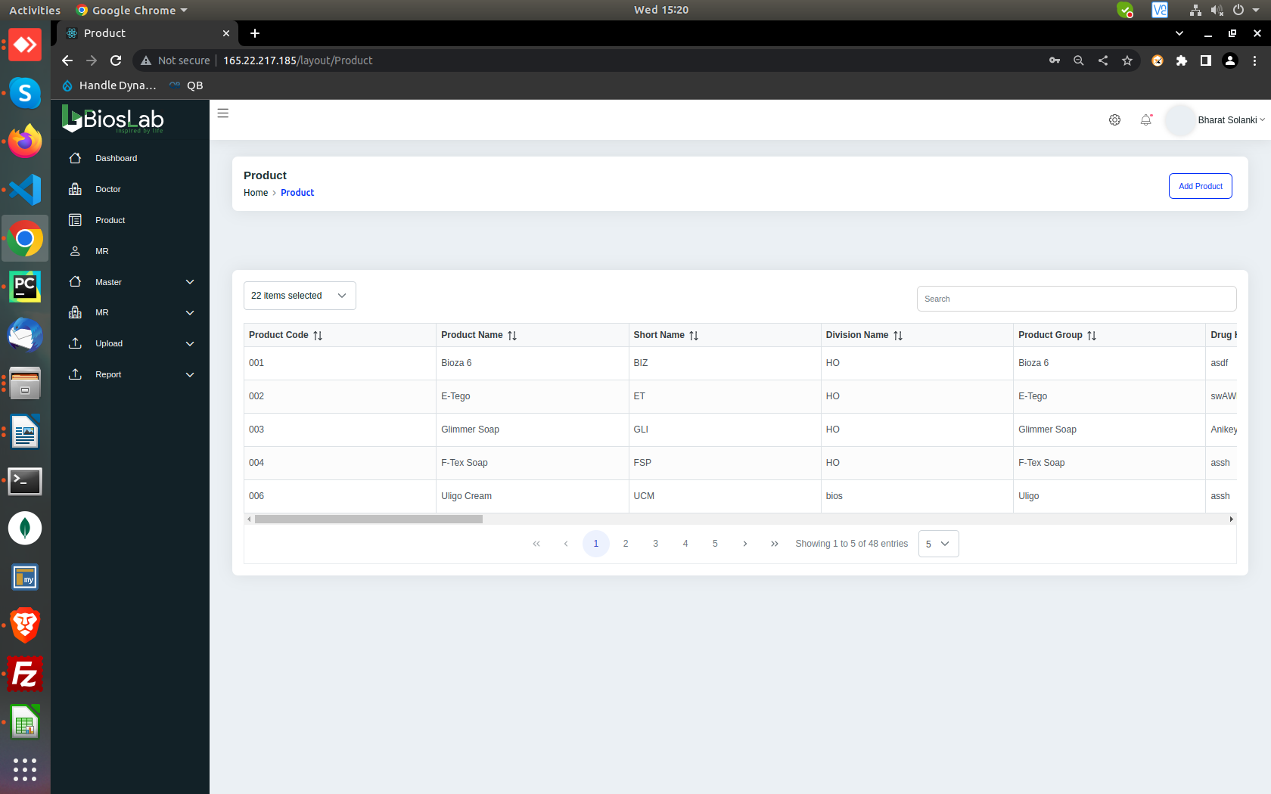
In the product menu, we can view the prodcuts that are already stored. These products can also be added, updates and deleted as per one’s need.
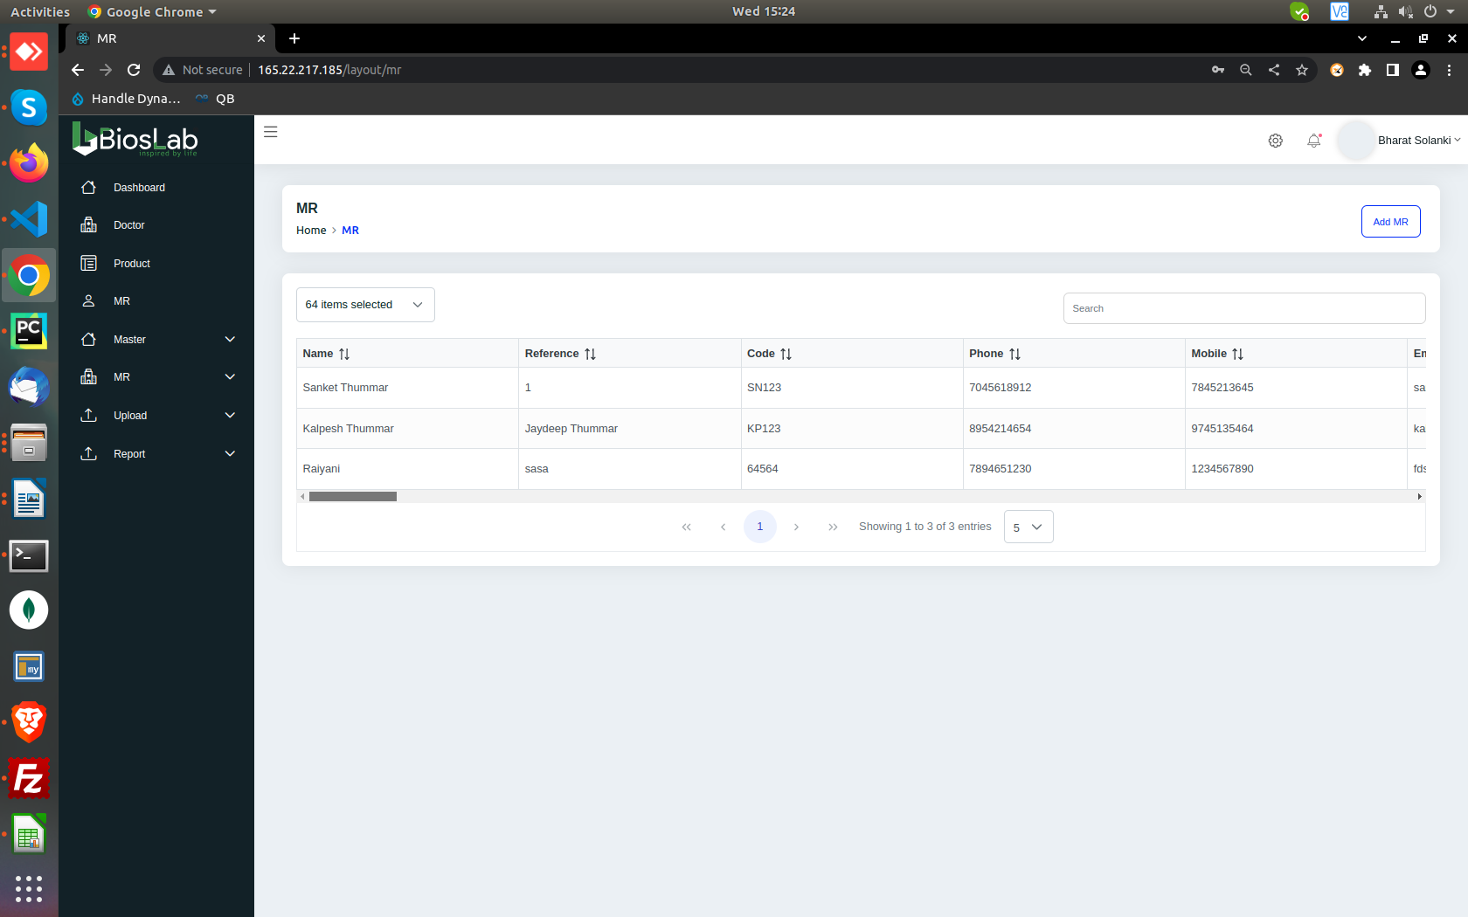
In the MR option, we get a page with very detailed information about all the MR.

With 65 different fields of Inforamtion required to create a MR, we can be assured of getting pretty much every detail we may need of any MR.

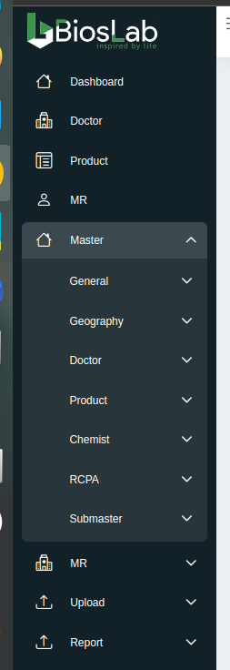

As we can see, there are several fields we can alter and view in the option “Master”.

Here, The option General has three fields. CFA(Clearing and Forwarding Agent),
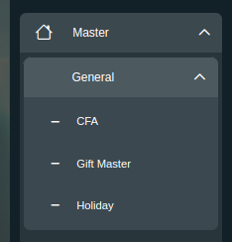
Gift Master and Holiday

CFA(Clearing and Forwarding Agent)
which maintains the stock (storage and supply) of a company and provides pharmaceutical products to stockists, and stockists provide them to retailers. So, having their information is essential for a product like BIOS LAB.

We can get a detailed overview of different CFAs from the CFA option.

There are also 2 other options of Gift master and Holiday. Gifts are given to employees who exceeds the expectations and to the doctor and others for various reasons. We can keep a track on this in the “Gifts Master” option.

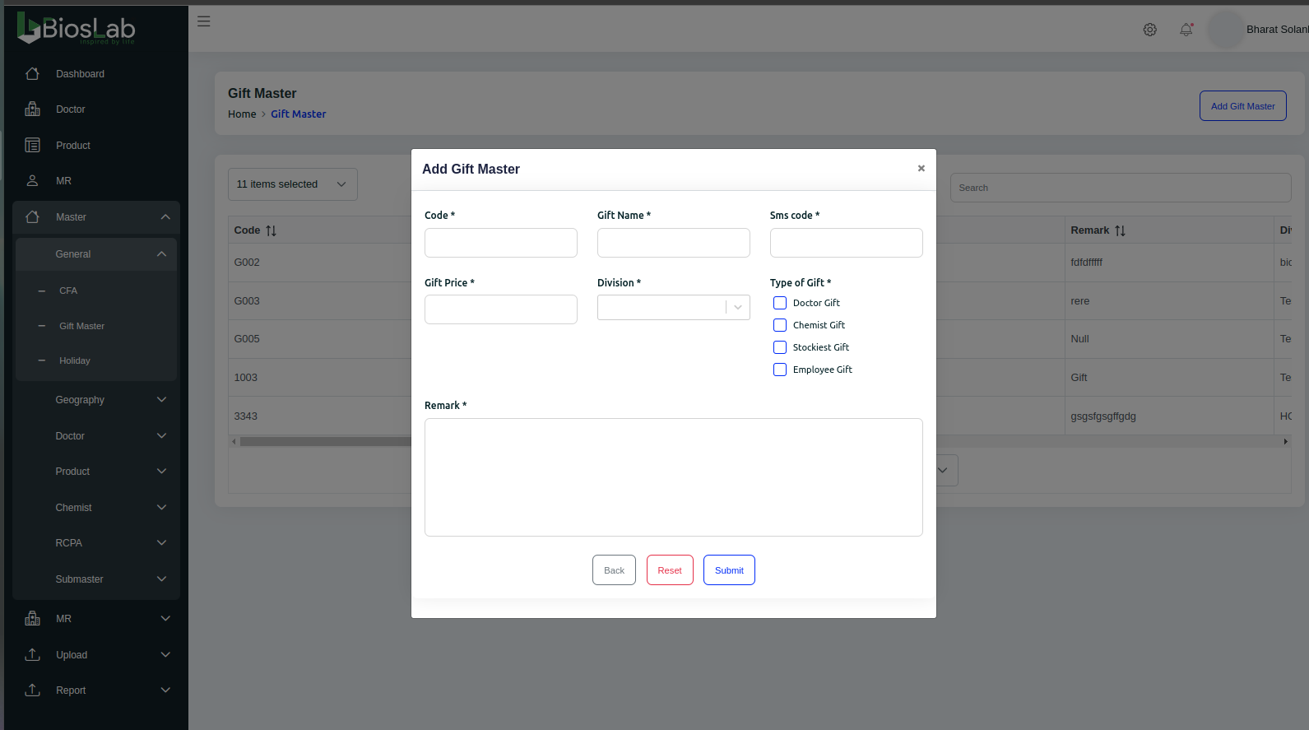
Holiday is to apply for holidays with appropriate reasons given. It get approved/disapproved by the admin based on various reasons.

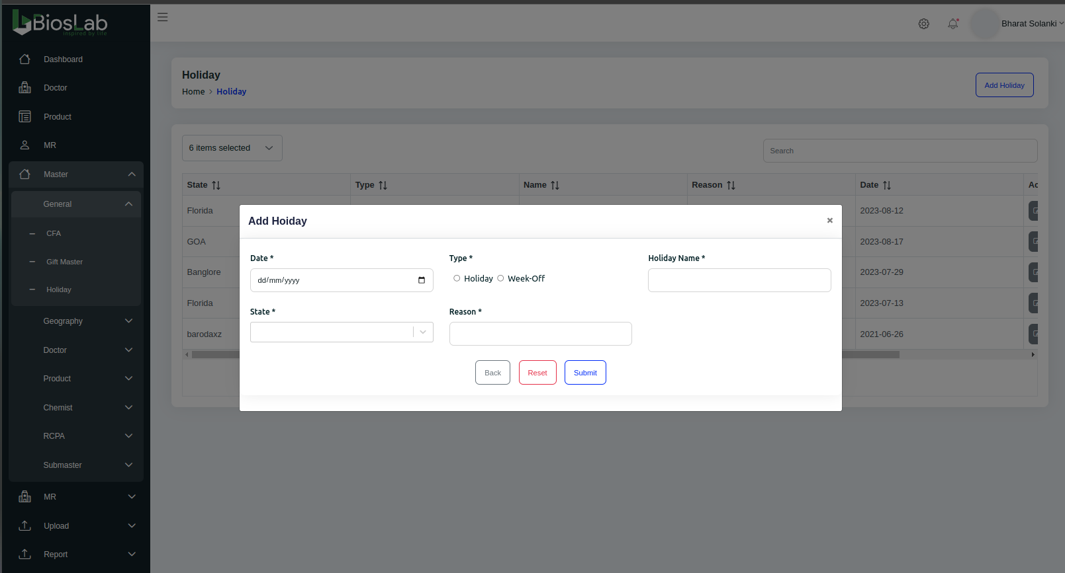
Option Geography is pretty much self explanatory, It reflects the basic countries, city, and pincode.

The options of Doctor, Products, and Chemist in the Master field, are basically to speed up the creating the new Doctor and products by adding the common used information prior. So, while creating a new doctor or product we do not have to manually all these informations, we can just select them from their respective menus. These information are like doctor specialities, product type and product class and many others.

RCPA(Retial Chemist Prescription Audit):
RCPA is a sales survey tool which is used to gather the Information of “Competitor”. It is a mandatory tool in Pharma sales and marketing which can be considered as a Survey/ Comptetitve intelligence and decision making tool which is used by MR and Managers to improve the quality of the “Field Work”.

Submaster:
Submaster field contains different fields of information which is used across the site for various detail retrieval.

MR:
MR field is one of the most important if not the most important across the website which is used by MR to track their efforts.
It contains the data regarding where a MR will be touring to visit different Doctors, Hospitals and chemists of different cities. Which route they’ll be taking and who will be they visiting while they are on their Tour.

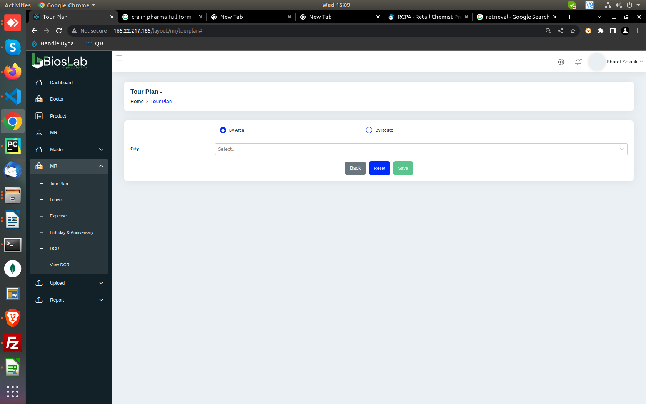
It also contains the information regarding to their leaves, how much money they spent during a particular tour, on what did they spend the money like travel, food, accomodation etc.

They can also check the Birthdays and anniversary of all the doctor in the system and can plan their tour accordingly.

DCR( Daily Call Report):

It is where a MR records his daily work data which includes the number of doctors, chemist met in the day and also various details of samples distributed. Overall it is the summary of work done for a day.
A MR can add, view this information, filtered by Doctor, Hospital and Chemist.
